SMART QUEUING

SYSTEM

LOW GEE CHEN

SESSION 2015/2016

FACULTY OF INFORMATION SCIENCE & TECHNOLOGY

MULTIMEDIAUNIVERSITY

SEPTEMBER 2015

SMART QUEUING SYSTEM

BY

LOW GEE CHEN

SESSION 2015/2016

THE PROJECT REPORT IS PREPARED FOR

FACULTY OF INFORMATION SCIENCE & TECHNOLOGY

MULTIMEDIA UNIVERSITY

IN PARTIAL FULFILLMENT

FOR

BACHELOR OF INFORMATION TECHNOLOGY

B.I.T. (HONS) SECURITY TECHNOLOGY

FACULTY OF INFORMATION SCIENCE & TECHNOLOGY

MULTIMEDIA UNIVERSITY

SEPTEMBER 2015

© 2015, Universiti Telekom Sdn. Bhd.ALL RIGHTS RESERVED

Copyright of this report belongs to Universiti Telekom Sdn. Bhd as qualified by Regulation 7.2 (c) of the Multimedia University Intellectual Property and Commercialization policy. No part of this publication may be reproduced, stored in or introduced into a retrieval system, or transmitted in any form or by any means (electronic, mechanical, photocopying, recording, or otherwise), or for any purpose, without the express written permission of Universiti Telekom Sdn. Bhd. Due acknowledgement shall always be made of the use of any material contained in, or derived from, this report.

DECLARATION

I hereby declare that the work have been done by myself and no portion of the work contained in this thesis has been submitted in support of any application for any other degree or qualification of this or any other university or institute of learning.

____________________

LOW GEE CHEN

Faculty of Information Science & Technology

Multimedia University

Date:

ACKNOWLEDGEMENT

First of all, I would like to thank everyone who had brought their kindness to me in assistance and encouragement that result in the successful completion of this project. Most importantly, I would like to express my sincere thankful to my supervisor, Mr Liew Tze Hui for the priceless advice, valuable guidance and his enduring patience throughout the entire progress of this project. Without his assisted and supervised, I am pretty sure that I could not be able to finish complete this project in time with the desired result.

In addition, I also want to thank my family because they always being at my side giving me support when I met some question and problem while doing this project. When I lack of confidence while doing this project, they always exhort me not to give up easily. Last but not least, I would like to thank to my friend as well because they helped me save up a lot of time by giving me some useful opinion.

ABSTRACT

In this project, I am concentrated on searching the best approach and solution to bring a great convenience who always have to wait in a queue. Study and understanding are done on the existing queuing system in order to find out more features which can add into this project. Smart queuing system is created in this project, it is a mobile application usable in android handset. Smart queuing system will be the best approach in order to overcome the queuing problem.

Smart queuing system provided some features in order to bring the advantages for the user. Users are able to obtain an online e-ticket instead of taking the ticket at the branches. Besides, Wi-Fi connectivity is needed when operating smart queuing system. Last but not least, SMS notification will send to the user to notify them about their queuing number is almost reach. Since SMS will send to user hand phone to alert user about the queue is almost reach, so that user do not afraid to miss out the service anymore.

TABLE OF CONTENTS

DECLARATION III

ACKNOWLEDGEMENT IV

Abstract V

Table of contents VI

List of tables IX

List of figures X

LIST OF ABBREVIATIONS/ SYMBOLS X

List of appendices XIII

CHAPTER 1 INTRODUCTION 1

1.1 Overview 1

1.2 Problem Statement 2

1.3 Project Objectives 2

1.4 Project Scope 3

CHAPTER 2 LITERATURE REVIEW 4

2.1 Overview 4

2.2 Queue Management Concept 4

2.3 Type of Queue Apply in Queuing System 5

2.4 Existing Queue Management System 7

2.5 Bluetooth Based Queuing System 11

2.6 Compare Existing Software 12

2.7 Conclusion 17

CHAPTER 3 METHODOLOGY 18

3.1 Software Development Methodology 18

3.2 Communication Phase 19

3.3 Planning Phase 19

3.4 Modeling Phase 20

3.5 Construction Phase 20

3.6 Deployment Phase 21

3.7 Gantt Chart 22

3.8 Hardware Requirements 23

3.9 Software Requirements 23

CHAPTER 4 IMPLEMENTATION PLAN AND SIGN 24

4.1 Overview 24

4.2 Application Development Tool 24

4.3 Propose Design 25

4.4 Interface Design 37

CHAPTER 5 THE SOLUTION 38

5.1 System Functions and Interfaces 38

CHAPTER 6 THE IMPLEMENTATION PROCESS / RESULT 50

6.1 Preparations 50

6.2 Setup Eclipse Integrated Development Environment 50

6.3 Setup Android Software Development Kit 51

6.4 Get Ticket 51

6.5 View My Ticket 52

6.6 View Serving Ticket 52

6.7 Cancel Ticket 53

6.8 Connection.php 53

6.9 SMS.php 54

6.10 Ticket.php 54

6.11 View-my-ticket.php 55

6.12 Get_current_next.php 55

6.13 Ticket.php 56

CHAPTER 7 Testing / evaluation of findings 57

7.1 Integration Testing 57

7.2 Validation Testing 59

7.3 Security Testing 59

7.4 Mobile Testing 60

7.5 User Evaluation of the System 60

7.6 Questionnaire 64

CHAPTER 8 Conclusion 66

REFERENCES 67

APPENDICES………………………………………………………………….…..68

LIST OF TABLES

**Table 2.1: Comparision Table in Related Existing System**..................................17

**Table** **3.1: Hardware Requirements**………………………...................................22

**Table** **3.2: Software Requirements**……………………….....................................23

**Table 7.1: Integration** **Testing Report**……………………...................................58

**Table** **7.2: Activity Validation**……..………………………..................................59

**Table** **7.3: Mobile Testing with Different Operating system**...............................60

LIST OF FIGURES

**Figure 2.1: Stand Alone Queue System.** 8

**Figure 2.2: Operation of Stand Alone Queue System** 8

**Figure 2.3: Advanced Queue System** 9

**Figure 2.4: Operation of Advanced Queue System** 10

**Figure 2.5: Centralized Control Queue System** 10

**Figure 2.6: Bluetooth Queue System** 11

**Figure 2.6.1: Interface Screen of Bluetooth in Client Phone** 11

**Figure 2.7: Sample of System Configuration** 13

**Figure 2.8: Procedure of Online e-Queuing** 14

**Figure 2.9: Example of SMS notification** 17

**Figure 3.2: Gantt Chart for Final Year Phase 1** 19

**Figure 3.3: Gantt Chart for Final Year Phase 2** 22

**Figure 4.1: Client-Server Architecture** 25

**Figure 4.2: Flow Chart of User Phone** 27

**Figure 4.3: Sub-Process in Flow Chart** 28

**Figure 4.4: Flow Chart Diagram of Company Staff User** 29

**Figure 4.5: Use Case diagram of System** 30

**Figure 4.6: Context Diagram** 31

**Figure 4.7: Data Flow Level 0 Diagram** 32

**Figure 4.8: Data Flow Level 1 Diagram for Process 1.0** 33

**Figure 4.9: Data Flow Level 1 Diagram for Process 2.0** 34

**Figure 4.10: Data Flow Level 1 Diagram for Process 3.0** 35

**Figure 4.11: Data Flow Level 1 Diagram for Process 4.0** 36

**Figure 4.12: Entity Relationship Diagram** 37

**Figure 5.1.1: Login** 38

**Figure 5.1.2: Register** 39

**Figure 5.1.3: MainMenu** 40

**Figure 5.1.4: Get Ticket.** 41

**Figure 5.1.5: View My Ticket** 42

**Figure 5.1.6: View Serving Ticket** 43

**No table of figures entries found.****Figure 5.1.10: Dummy User Page** 46

**Figure 5.1.11: Ticket for Dummy User** 47

**Figure 5.1.12: Update Serving Ticket** 48

**Figure 5.1.13: SMS notification** 49

**Figure 6.1: Source Code for Get Ticket Function** 51

**Figure 6.2: Source Code for View My Ticket Function** 52

**Figure 6.3: Source Code for View Serving Ticket** 52

**Figure 6.4: Source Code for Cancel Ticket Function** 53

**Figure 6.5: Source Code for Connection.php** 53

**Figure 6.6: Source Code for sms.php** 54

**Figure 6.7: Source Code for Ticket.php** 54

**Figure 6.8: Source Code for View-my-ticket.php** 55

**Figure 6.9: Source Code for Get_current_next.php** 55

**Figure 6.10: Source Code for User_cancel.php** 56

**Figure 7.1: User Evaluate the Difficulties Level of the System**  61

**Figure 7.2: Opinion on User Friendly Interfaces** 61

**Figure 7.3: Opinion on Convenience of the System** 62

**Figure 7.4: Opinion on Learning of the System** 62

**Figure 7.5: Opinion on Sharing the System to others** 63

LIST OF ABBREVIATIONS/ SYMBOLS

SDK Software Development Kit

ADT Android Development Tools

EWT Estimated Wait Time

FIFO First In First Out

LIFO Last In First Out

SPF Shortest Proceed First

SQ Single Queue

LIST OF APPENDICES

**Appendix A: Meeting Log** 68

**Appendix B: Checklist for FYP Submission** 69

# INTRODUCTION

### Overview

Nowadays, we encountered many real world problems which are about queues, and we could find that those customers always conflict with each other because of the vying position in the queue. We could easily find a single best solution for single objective problem that could best satisfy our needs. In contrary, there may not exist a solution that is best with respect to all objectives. However, there are existence of a set of solutions which are superior to the rest of solutions in the search space when all objectives are considered. For customer, waiting in line or queuing is annoying (Obamiro, 2013) or negative experience (Scotland, 1991). Consequently, queuing system is concerned with reducing customer wait times and also enhanced customer satisfaction.

In this advanced era, physical waiting lines already outdated. However, smart queuing system refuse to utilize the physical waiting lines, which mean they replace the physical waiting lines with virtual waiting lines. Aside from that, with over 85% of the adult population already have at least or more than one mobile devices, it is a best timing to practices use mobile experience to improve customer service capabilities in a strategy way.

In this project, mobile application provided compelling graphic images in real time and also offers interactive multimedia in order to make a good customer satisfaction. Aside from that, user-friendly of the interface will easy to manipulate well by user even they are just a newbie in using smartphone. With the Wi-Fi is connected in mobile application, user can access the application with a login ID and password. In contrary, the application will stop working where the particular places is without the Wi-Fi connection.

In the application, a new user can register as a member by handily as well as without spending a lot of time during the registration. Furthermore, android mobile based of the smart queuing system is the proposed to be a great and convenience solution for the customer. Besides, SMS notification will send to the user smartphone as a reminder to avoid user miss out ticket. Therefore, this paper is going to express the more detail and understanding in order to achieving the project’s objective.

### Problem Statement

We can observe that queues (waiting line) are very often in our daily life. Think for a moment how much time is spent in one's daily activities waiting in some form of a queue waiting for breakfast; stopped at a traffic light, slowed down on the road, delayed at the entrance, queue for access to an elevator, holding the telephone as it rings, and so on. Queuing in the long queue is very annoying especially when we are queuing for services in post office, migration, bank and so on. Therefore, a queue is form when the demand for a service is exceed its supply (Kandemir-Cavas&Cavas, 2007).

When the number you get to wait for the service is too far with the present number, there will be a period of time before it is your turn. A lot of stuff are waiting for us to be done during the waiting time. While waiting for your turn, you have the ample time to do other kinds of stuff such as going for a cup of coffee, shopping, and etc.

### Project Objectives

The objectives of the project can be written in point form, as shown below:

* To develop an interactive Smart Queuing System
* To investigate the usability issues of the system with user

### Project Scope

This project is to create an Android-based application that provides a smart queuing system to users. There are two main sides in the system which are belongs to client side and serer side. First of all, client request for a ticket send to the server and the server will response to the client. The interaction between client and server is done through the request and response.

Now, user can get the queuing ticket in an easy way by just have to clicking a smartphone application with the Wi-Fi connection is available. In this project, PHP script is needed in order to process the request from client side to server side. There are still some available features in the application which are includes view queuing status, registration and view current number.

Besides, a SMS notification will send to user as a reminder about their queuing ticket is nearly reach. The purpose of this SMS notification reminder is to avoid the careless user miss out their ticket when they are not around inside bank. By this way, user can go back to the bank to have the service after they receive SMS. Moreover, this SMS method is also enables to all kind of version of phone to receive SMS and without the extra MMS or graphic related features are added.

# LITERATURE REVIEW

### Overview

Queue model and queue management system were discussed to study about how the queue system works and also the basic operation of the queue management system. Besides that, the queuing theory and the process of queuing were also discussed here. The research done on some existing queue management system discussed about a few of the current used methods in developing queue management system. However, the used methods are among the references contributed to the design of this project. The existing queue management system has bringing the more understanding and more detail in queuing system.

### Queue Management Concept

There are many types of queue model in queue system such as FIFO (First In First Out), LIFO (Last In First Out), SPF (Shortest Processed First), SQ (Single Queue), Diffuse Queue, Multiple Queues and so on.

First in first out (FIFO) principle provided the service with most fairly, customer who is served at the first is mean that the customer has been waiting the longest time in the queue. The FIFO concept normally will use in ticket machine of smart queue system. The first person will be serve at the first and the system will be update afterward. This means that the number will be taken out and the new number will be update to then system when any client using the system. Last in first out (LIFO) principle serves customers one at a time which is same with FIFO principle. In contrast, LIFO states that customer with the shortest waiting time will be called to serve first. In LIFO, customers are served as equal in processor sharing. Besides, network capacity is also shared between customers with others customer, they may effectively facing the same delay. In addition, customers contain with the higher priorities are served prior to the others customer.

While in SPF, this principle is describes a model where the short anticipated length are served with sooner. SPF is more often used by supermarket, for example customers with 10 or lesser than 10 item in a supermarket are assigned to the specific counter which is only serve the customer with less buying item. The problem of the SPF is only one which is the customer needs explanation why those customer are being served first other than the simple First In First Out (FIFO) principle.

Single queue is queuing like a one straight line format. When a customer is done of his/her service, the format of the queue discourages will pushing forward one by one. Aside of that, there is also a tangible reassurance that all of the customer will be served in fairly.

In multiple queues, it states that we can always perceive the multiple queues in the supermarkets. The example of the diffuse queue is like take-a-ticket queue models. In diffuse queue, there is no have formal queue line but customer register place in the process with a ticket.

### Type of Queue Apply in Queuing System

There are many type of queuing system apply by different company. Sometimes, company can choose their queuing type based on their conditions. For example, the condition can based on the company budget or as well as the size of the company. A rich company perhaps can apply the modern queuing system which is including the estimated time of queue together with the ticket number. Besides, customer may have the good impression to the particular company which have provided a best queuing system.

#### Invisible queue

Invisible queue is mean that where customer are queueing in a queue without knowing the current queue condition, for example there does not announce the estimate time for user when queuing (Chua, 2012). Some customer who are rush of time and they are not informed of waiting time when queuing, they might leave the queue even for those who eventually reach their turn.

#### Visible queue

With the visible queue, customer will be informed of the estimated waiting time when queuing in visible queue. Due to this type of queue, customer can easy to manage or plan their time and determine the best use of their schedule. It may save up a lot of time with a great planning schedule. Moreover, customer may make the decision whether they want to leave or remaining in the queuing line after they hear the estimated wait time.

#### Virtual queue

Virtual queue provide customer with information about current queue conditions and present them with options for handling their wait (Ramasamy, 2012). In virtual queue, customer are informed of their estimated wait time as well and customer will keep holding or receiving a return call when there is their turn to have the services.

### Existing Queue Management System

In this multi-population life, we can see that waiting in lines is a part of our everyday life. The reasons of waiting in lines maybe due to congestion, overfilling or due to overcrowded (Chukwunoso, 2012). The service side such as customer service orientated companies and institutions always face the problem of unpredictable waiting and also lengthy queues will causing stress and tension among customers and employees which affect in efficiency decline. Queue Management has been a problem for many years in many domains including the Financial, Health Care, Public and Retail Sectors. In this age of technology it is not only important to organize the existing queue, but to gather statistics about the queue in order to identify trends that could be anticipated. Hence, there is a need in the society for the continuous development of a Queue Management System especially in moving counters.

There are several types of Queue Management System products in the market which can be referred for this project. The different types of systems are due to the targeting size of queue and the efficiency as well the size of the targeted company. There are Stand Alone Queue System, Advance Queue System and Centralized Control Queue System.

#### Stand Alone Queue System

The system is one to one relationship. It design is used for single counter with a single queue. Standalone queue system is suitable for small company because it is cheap and also easy to use. Besides, small company only managed to control one queue with one customer. In addition, this system will call the queuing number following by the sequence or randomly as preset. However, if the small company have many of the customers waiting for service, SMS notification is very helpful for user. Meanwhile, user does not need to wait in a physical queuing line up to a couple of time. Figure 2.1 illustrated a model of standalone queue system.

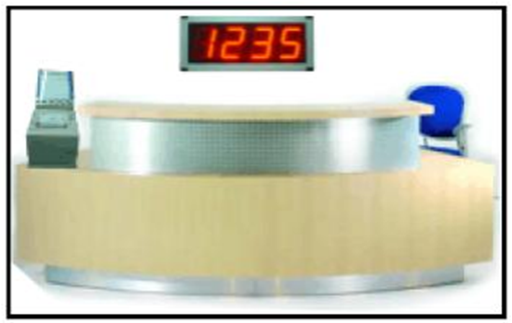

**Figure 2.1: Stand Alone Queue System**

The concept of Stand Alone Queue System is using First In First Out (FIFO) queue model. There is only one counter working in Stand Alone Queue System, meanwhile one counter is servicing all of the customer in different time. Figure 2.2 showing the operation of Stand Alone Queue System. By using this concept, all of the customer will be treated as equivalent, it is commonly implement in single service operation.

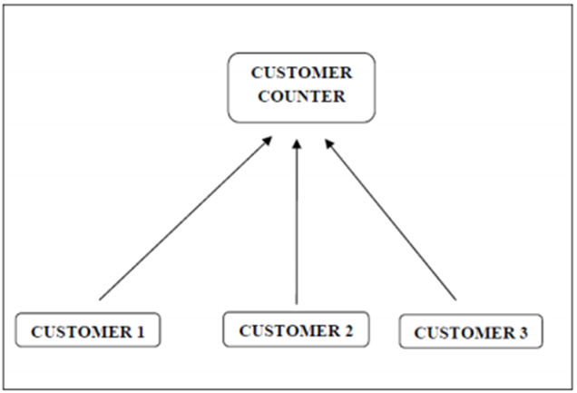

**Figure 2.2: Operation of Stand Alone Queue System**

#### Advanced Queue System

Advanced Queue System is the upgraded of Stand Alone Queue System. It is more reliable and high efficiency than the previous queue system. Mostly, this system is used in banks or the companies which are providing multiple services in different queues as well as queue in distinct counters. Besides that, different services can be categories in different counter which mean more than one counter can be serve the different customer at the same time. Therefore, the ticket number will display in TV screen in order to assign customer to specific counter. Figure 2.3 shows the model of Advance Queue System.

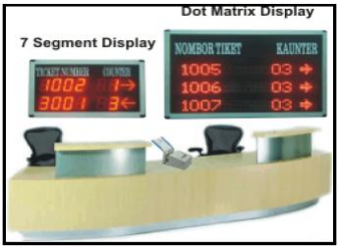

**Figure 2.3: Advance Queue System**

Figure 2.4 showing the operation of Advanced Queue System. In this figure, there have more than one customer counter is operating and customer will assign into the different counter based on different type of the services. For example, the numbering part can also separate into two categories as well, which mean the numbering holder with small number is assign to a normal counter. In contrast, big number holder will assign to a counter which is able to support and various services are applicable.

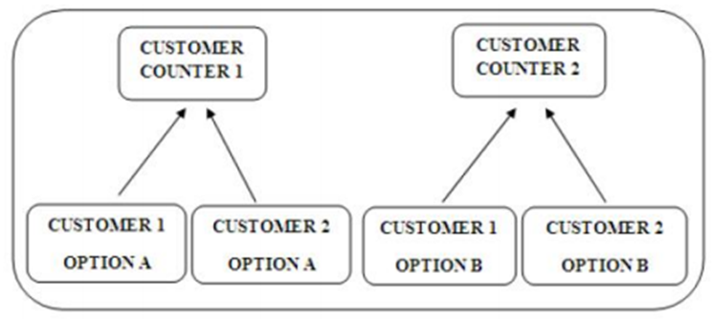

**Figure 2.4 Operation of Advance Queue System**

#### Centralized Control Queue System

Centralized Control Queue System is different with standalone queue system and advanced queue system. The different part is because this system is a high-end server-based queue system. In addition, the queue server can be supported up to 20 departments and each department can have the different services as well as several different counters up to 32 services and 60 counters. Centralized control queue system is compatible in network it means that each department which is situated in different building or even different region can communicate between each other through LAN or INTERNET. Figure 2.5 is a high-end PC-based queue system.

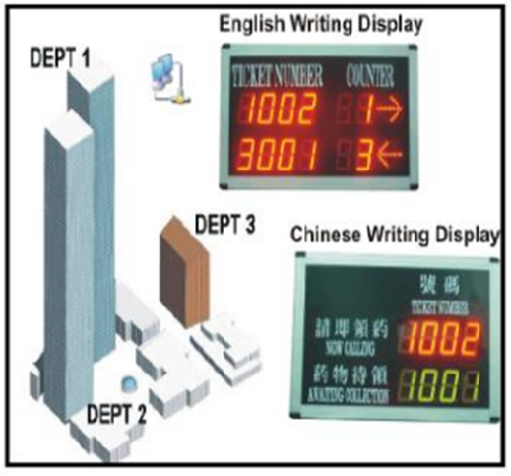

**Figure 2.5: Centralized Control Queue System**

### Bluetooth Based Queuing System

Bluetooth based system is an advanced ways in queuing system. This system is very suitable use for small company because it is designed to a low cost system. It is more easily to help user in getting a numbering ticket by connecting to the bluetooth between two devices. Once the bluetooth is connected, the reader device side will receive the user unique information and sending the request to the receiver device side in order to get an e-ticket. Figure 2.6 is interface of bluetooth queuing system and 2.6.1 is the screenshot of bluetooth in client phone.

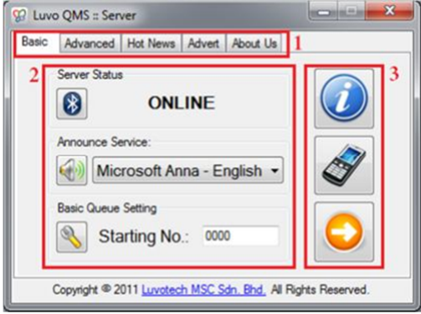

**Figure 2.6: Bluetooth Queuing System**

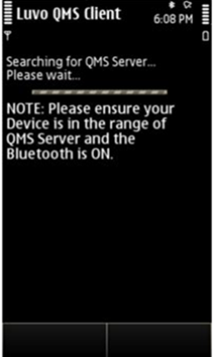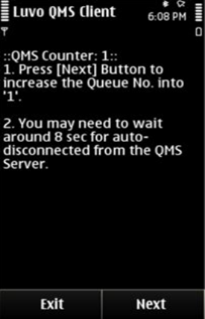

**Figure 2.6.1: Interface Screenshot of Bluetooth in Client Phone**

#### Bluetooth Queuing System’s Features

This system is support multiple devices connection to server simultaneously. Because it is and bluetooth base, it will disconnect when the devices are too far. Thus, it will help to save up the battery once the devices are no connected. Besides that, there have some features in this system. It provided a user friendliness interface and also supported numbering announced service. Besides, it is a wireless control via bluetooth that can support multiple devices connection to QMS server simultaneously. Bluetooth application will auto disconnect for the battery saving as well as a low cost application.

#### Limitation of Bluetooth Queuing System

Using bluetooth as based system will cause the range problem. Range is limited between the devices which mean bluetooth can only connected in a short range. Besides, the signal of using bluetooth is much weaker than using Wi-Fi.

### Compare Existing Software

In order to ensure the smoothness of my system, I have carried out study on the existing smart queuing system. There have many different type of approach to obtain the queuing ticket. Many of the company need to have a queuing system in order to control the queue. The queuing system is a very important role when controlling the queue. The unpleasant experience of waiting in line can often have a negative effect on the rest of the customer’s experience with a particular company. The way in which managers address the waiting line issue is critical to the long term success of their firms (Davis, 2003). Section below is the literature review about smart queuing system.

#### QtracVR Virtual Queuing System

This system is developed by lavi industries. This system is a queuing system that we can observe in our daily life. The development objective is to improve the service efficiency and the customer satisfaction. However, with this advanced technology virtual queuing system, no longer complaint by the customer anymore. This system will enhanced the service efficiency and effective digital signage because of heighten up the customer’s experience. Moreover, the system is more effective at dispersing waiting crowds. In addition, it also can create a pleasant environment.

Firstly, it is a paper ticketing system which means that customer needs to go to the specific place such as post office, bank and more in order to register and receive a ticket by manually. Thus, the ticket number is different between each of the customer.

After received the ticket, customer can relax, browse or either leave the place for while waiting to be served, it helping to reduce perceived wait times and increasing overall satisfaction. Besides that, there have a monitor can display promotional stills or advertising videos. When customer ticket number is reach, the service agent will update the service button on their screen directly from their PC. Once the number is updated by the service agent, the current serving number will display on the LCD screen and the customers are just allowed to have their services. Figure 2.7 illustrates the sample system configuration.

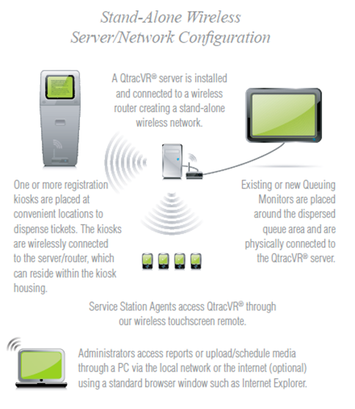

**Figure 2.7: Sample of System Configuration**

#### Online e-Queuing System

This online e-queuing system is a product produced by a company named VTL-Solutions Ltd. The main company is located in Hong Kong. The development objective of this system is to save the time and queuing up without any paper ticket. This system is a paperless ticketing system, which means the user does not need to go to the reception place to press the paper ticket manually.

First of all, online e-Queuing system must work with the Wi-Fi connectivity in order to get a ticket via mobile application. After that, user will receive a ticket number with a security code. Each user will have the different of the security code when receiving a ticket number. Besides, the best feature in this existing application is about the application itself will send a pop out notification to the user when queuing number is almost reach. The purpose of the security code is to authenticate with the agent when reach your turn. Therefore, show the e-ticket with the security code to the agent will get the service. Figure 2.8 is the procedure of online e-queuing system.

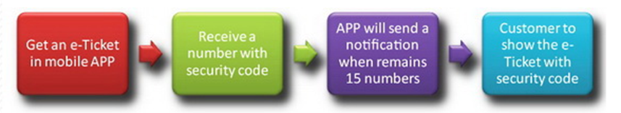

**Figure 2.8: Procedure of online e-queuing system**

##### Advantages

This system is much more convenient and efficiency than the old style paper tickets. With this system, user are also upgraded which mean that they do not need to wait for the tickets to arrive in the spot. However, the current mobile phone that installed the app will alert user when the number is nearly reach. Besides that, user’s mobile phone and the shop screen display are synced, it is very convenient to user for checking the ticket number in every single minute. The more feature in this system is to cancel the ticket by using mobile app. Thus, this system also can calculate the total number of the queuing.

#### Smart Queuing Management System

The system is customized made by KAPS LTD. This system is able to run in two methods which are stand alone or run in LAN AND WAN environments. In addition, it can accommodate third party integration with either external database or software application. It also includes a database and all of the events are stored in order to retrieve data or data evaluation.

Smart queuing management system can be paper based or paperless method. In paperless method, customers are queuing in the line without holding any paper ticket. In this system, the touch pads is provided in the reception place, the customer only have to key in their handphone number on the touch pad in order to get the services. After punches in the handphone number, customer will receives an SMS indicate them the number they are on the queue. In this time, customer can busy with their own business and do not afraid to miss their turn. A SMS will send to the customer handphone when there are about two people in front of the customer. Thus, customer must go back to the reception after received the SMS and get ready to be called. Lastly, LED notice board will display and call out the number when the number is reach.

##### Smart Queuing Management System’s Features

Smart queuing management system is a system that can support up to three service types and also 16 serving counters. Besides, daily efficiency reports help to estimate of the customer arrival time and also wait time to receive service. There have a high quality thermal printer to dispense the queuing numbers to the customer. The queuing numbers have clearly printed out the branch name, time and date of issues.

#### SMARTQUEUE®

SMARTQUEUE® by Business Smart Solution Pty Ltd is a queuing system that with many features inside. It is a successful product in multimedia queuing management system. The objective of the system is not only to overcome the long queue problem, yet this system is for high efficiency organization of queuing and also effective customer service with its ticketless system. Aside from that, it will record down all of the customer service transaction in order to have more improved in company performance.

##### SMARTQUEUE®’s Features

The main feature of this system has covered the company from customer service point to executive meeting room. For example, some queuing system is a visual-based queue management system which mean customer have to keep alert the numbering. Besides main feature, SMARTQUEUE® is flexible licensing structure that can handling, registering and managing an unlimited number of users. It is a simpler-to-use interface, there is no need any extra hardware like keyboard or mouse required as everything operates within the SOE (System Operating Environment). Moreover, the unique feature of the system is its ability to notify customer when service is turn approaches via SMS or e-mail.

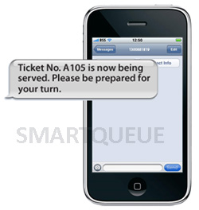

**Figure 2.9: Example of SMS notification**

### Conclusion

Smart queuing system derives a wide range with different method. Related existing software have summarized in a table as below. Table 2.1 shows the comparison between some types of existing system. The symbol “” meaning that the system is containing the feature in the system. In contrast, symbol “C:\Users\User\Desktop\Cross.PNG” is the opposite meaning with the tick symbol which mean the system does not have that feature in the system.

|  |  |  |  |  |  |  |  |  |
| --- | --- | --- | --- | --- | --- | --- | --- | --- |
| **Software** | **Comparison** | | | | | | | |
| **Terminal at branch** | **Online Get Ticket** | **Advanced Queue System** | **Internet Connectivity required** | **Notice by SMS** | **Portable queue system** | **Paper based ticket** | **Paper less ticket** |
| **QtracVR virtual queuing system** | C:\Users\User\Desktop\Tick.PNG | **C:\Users\User\Desktop\Cross.PNG** |  | **C:\Users\User\Desktop\Cross.PNG** |  | **C:\Users\User\Desktop\Cross.PNG** |  | **C:\Users\User\Desktop\Cross.PNG** |
| **Online e-Queuing System** | **C:\Users\User\Desktop\Cross.PNG** |  | **C:\Users\User\Desktop\Cross.PNG** |  |  |  | **C:\Users\User\Desktop\Cross.PNG** |  |
| **Smart queuing management system** |  | **C:\Users\User\Desktop\Cross.PNG** |  |  |  | **C:\Users\User\Desktop\Cross.PNG** |  |  |
| **SMARTQUEUE®** |  | **C:\Users\User\Desktop\Cross.PNG** |  | **C:\Users\User\Desktop\Cross.PNG** | **C:\Users\User\Desktop\Cross.PNG** | **C:\Users\User\Desktop\Cross.PNG** |  | **C:\Users\User\Desktop\Cross.PNG** |

**Table 2.1: Comparison Table in Related Existing System**

# METHODOLOGY

### Software Development Methodology

System development methodology is used to plan, structure and control the process of developing an information system. A broad variety of frameworks have been developed over the years for example waterfall method, v-shaped method, incremental method, prototyping method and many more. However, different framework has its own pros and cons, thus choosing the best suitable framework based on the type of the projects. Before decided which approach to be used in developing software, the consideration have to examine from different organizational, project, technical and team perspectives

The waterfall model has been widely used for software projects ever since 1970. This final year project is using waterfall model approach as its methodology. The waterfall activities are flow from one phase to another phase. Besides that, repetition to previous phase is allowed when the previous phase need corrections required and then flow once again from that phase. Figure 3.1 showed the phases of the waterfall model.

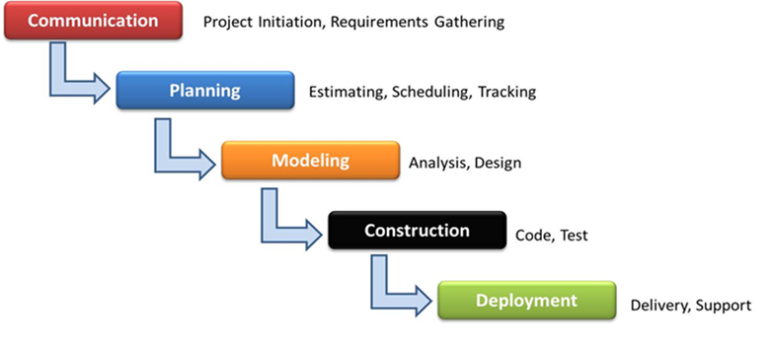

**Figure 3.1: A Waterfall Model**

### Communication Phase

It is the first phase of the methodology means project initiation which is used to communicate with the user or customer. This phase is critical to the success of the project. The purpose of this phase is to building up a team, software requirements gathering and negotiated between user and developer. The software requirements gathering can get from the customer interviews and surveys and so on. A side from that, this phase is indispensable in understanding the future of the project.

### Planning Phase

The purpose of the planning phase is to estimate the cost for the entire developments. Besides estimating cost, this phase also have to schedule the progress of works. All of these have to prepare by the developers themselves before coding the system. Developers have to understand the basic design, problem statements and the concept before coding. However, type of platform and also programming language are chosen as well.

### Modeling Phase

This phase consists of analysis and design. In order to get more understanding about the software, literature reviews (Chapter 2) in regards to the related software was conducted and analyzed by the developers. The related software will be compared to their software requirements so that it is still able to improve or adding requirement to the software. After confirm all the software requirement, the system is designed according to the requirements.

### Construction Phase

Construction phase consists of system coding and also testing. On receiving system design documents, work is divided into unit and the solution is constructed. The system separated into small part called as unit, which are merged in the next phase. At the same time, each unit is tested for its functionality. There are a few different type of testing are available which are unit testing, component testing, integration testing, system testing and acceptance testing. Unit testing is to test a program unit, basically develop by a single individual to determine that is free of data, logic or standards errors. Besides, component testing is to test individual software or hardware component as well as testing a group of related components. Integration testing is testing in software components, hardware components or both are combined together and tested to evaluate the interaction between them.

Aside from that, testing entire system is required if the system has achieved its requirements. Last but not least, acceptance testing is testing the final software which means verify if system meets the customer’s expectation requirement which is made by customer in the beginning of the project. This testing is to determine whether to accept the application.

### Deployment Phase

The last phase of the methodology consists of delivery and support. Delivery means the software is delivered to the user or customer when the software is done. However, support is needed for the user when some system issues occur and user require developer help them to overcome the problems. User is able to request for the updates or maintenance as well, thus developers can gather the feedbacks of the project and create a more perfect system in future projects.

#### Advantages and Disadvantages

There are consists of some advantages of using waterfall model. Firstly, it is easy to schedule for the task to be done within a specific time. Besides, waterfall model is clear partition between work and control. The errors in the software will be detected and asked for correction before proceed to another phases. It is easier for new member of the team to understand what to do next because the emphasis of the system is record down on paperwork in the waterfall method. Lastly, it may develop various types of software through this method in a short time.

For the disadvantages of waterfall model, this methodology may get the requirements list from the customer even after the communication phase. This project is not always partitioned in a flexible way. Many problems occur when one phase are never solved completely during the same phase. Aside from that, the testing period is come too late, therefore this may waste a lot of time and money.

### Gantt Chart

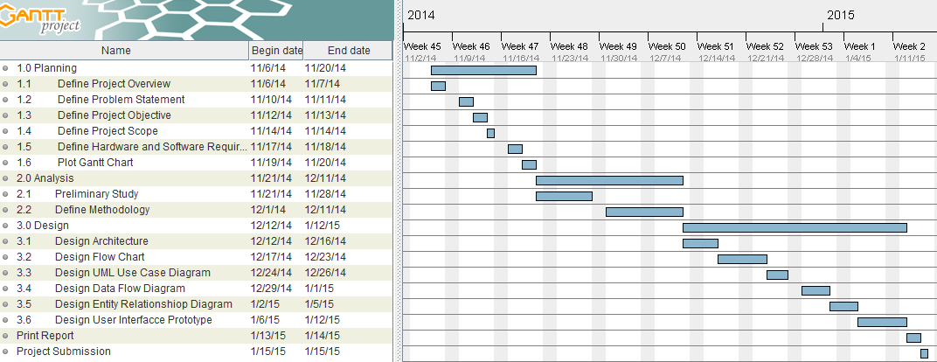

**Figure 3.2: Gantt Chart for Final Year Project Phase 1**

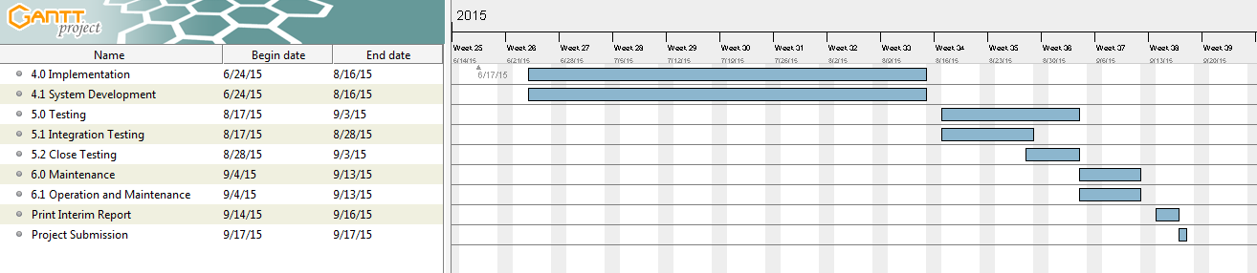

**Figure 3.3: Gantt Chart for Final Year Project Phase 2**

### Hardware Requirements

Table 3.1 shows the list of hardware requirements for the project development.

**Table 3.1: Hardware Requirements**

|  |  |
| --- | --- |
| **Hardware** | **Requirement** |
| Computer System  (Acer Aspire 4830TG) | Window 8 Operating System  4GB DDRIII Memory |
| Android Mobile Phone | Android Operating System |

### Software Requirements

Table 3.2 shows the list of software requirements for the project development.

**Table 3.2: Software Requirements**

|  |  |
| --- | --- |
| **Activity** | **List of Software** |
| Documentation | Microsoft Word 2013  Microsoft Visio 2013 |
| System Development | Eclipse Integrated Development Environment  Android Software Development Kit  PHP  MYSQL  Web Server |
| Testing | Android Software Development Kit |

# IMPLEMENTATION PLANING AND DESIGN

### Overview

The overview of development cycle for the smart queuing system is discussed by using diagram for outlining the system structure. The purpose of each diagram is to make clearer and more understanding about the system. Therefore, different diagram have its own description and explanation of the system. The diagrams which are use in the implement design are flow chart diagram, use case diagram (UCD), data flow diagram (DFD), entity relationship diagram (ERD) and interface design.

### Application Development Tool

Every application need to have a development tool in order to create or establish the application. Without the development tool, developer cannot even develop an application successfully and perfectly. This project is to create an application in an android smartphone. Therefore, the details of the development tool for this final year project will explain future at below.

#### Platform

The platform of the application in this final year project is using android based as platform. Nowadays, android is a very famous platform for mobile application development, yet it provides a rich application framework that allows user to create innovative apps or game for mobile devices in Java programming language. One of the popular reasons is because the android is stays open source.

#### Tools

ADT (Android Developer Tools) is a recommended tool for the beginner of Android developers. ADT is free package and also is a plugin for Eclipse which includes a set of tools that are integrated with the Eclipse IDE. ADT provides many features such as GUI access to many of the command line SDK tools, UI design tool for rapid designing and prototyping as well as establish the application user interface.

### Propose Design

Before the system start to operation, users require to login their account in order to proceed. The system will be built to operate in real time method, updating the ticket number, view current ticket number, view queuing status, cancel the ticket and lastly notifying customer by SMS when ticket number is almost reach.

#### Client-Server Architecture

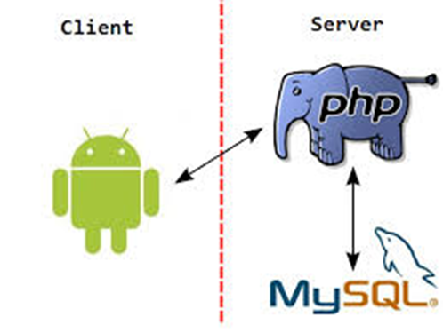

**Figure 4.1: Client-Server Architecture**

This project is based on the client and server architecture. Mobile phone is acts as the client while the server consists of PHP server and MySQL database. Firstly, the application sends a request to the server. Then, PHP server will process the request and interact with MySQL database. Thus, PHP server sends the response back to the application.

First of all, this application is need Wi-Fi connectivity in order to run the application and get an online ticket with an android handphone. After accessing the Wi-Fi, the users are able to send the ticket request from the application through Wi-Fi connectivity to the server. Aside from that, server will response to the application after get the retrieve and updated data from the database. In this moment, an SMS notification will send to the user’s phone to alert the user about their queuing ticket number is almost reach. This remind notification bring the advantage to the user in order to avoid user miss out their ticket.

#### Flow Chart Diagram

Flowchart is a simple and intuitive illustration of what happens in a workflow, what activities can be done in parallel, and whether there are alternative paths through the workflow. The diagram shows the processes of the system and including from the beginning until the end of the application. Figure 4.2 show the flow chart diagram of user phone in mobile application and figure 4.4 show the flow chart diagram of company staff user.



**Figure 4.2: Flow Chart of User Phone**

##### Sub-process in Flow Chart

  

**Figure 4.3: Sub-process in Flow Chart**

There are four sub-process of process in the figure above. Each of the diagram is to show the how its own process flow. These first of the sub-process are come from get ticket process, follow by view my ticket process, view serving ticket process and cancel ticket process.

#### Flow Chart Diagram of Company Staff User



**Figure 4.4: Flow Chart Diagram of Company Staff User**

#### Use Case Diagram

Use Case Diagram (UCD) is a graphic description of the system interaction among the elements. Besides, use case is a methodology used in system analysis to clarify, identify, and organize system requirements. UCD is a scenario that describe “thread of usage” for a system (Pressman, 2009). The project’s UCD is as seen in the figure below.



**Figure 4.5: Use Case Diagram of System**

#### Data Flow Diagram

In this section, data flow diagram is to describe how the user interacting with the system. First of all, user have to login to the system before they start using. A login is required, there will pop out an interface for user to key in the user ID and password. Users are able to use the system once they successful login. From the general to more detail about the system, the system data flow diagram between user and system can be illustrated in figure 4.6, 4.7 and 4.8, 4.9, 4.10 and 4.11.

##### Context Diagram



**Figure 4.6: Context Diagram**

##### Data Flow Level 0 Diagram



**Figure 4.7: Data Flow Level 0 Diagram**

##### Process of 1.0



**Figure 4.8: Data Flow Level 1 Diagram for Process 1.0**

##### Process of 2.0



**Figure 4.9: Data Flow Level 1 Diagram for Process 2.0**

##### Process of 3.0



**Figure 4.10: Data Flow Level 1 Diagram for Process 3.0**

##### Process of 4.0



**Figure 4.11: Data Flow Level 1 Diagram for Process 4.0**

##### Entity Relationship Diagram

Entity Relationship Diagram (ERD) is a data modeling technique that illustrates data entities of the system as well as the relationships linked to each other among the entities. Moreover, ERD is also a conceptual model of data used to on behalf the entity framework infrastructure. In ERD, the relationships between two data entities are correlated with modality and cardinality. Thus, modality could be either 0 or 1, but cardinality could be 1 or many. Figure 4.12 illustrates the entity relationship diagram of the system.



**Figure 4.12: Entity Relationship Diagram**

# THE SOLUTION

### System Functions and Interfaces

In this project, there are some interfaces needed to be design for the interactions between users and program. The design in this project is aimed to create a user friendly and interesting environment for the users when operating the system. Therefore, it is easy to get user’s gladness when using the system.

#### Login

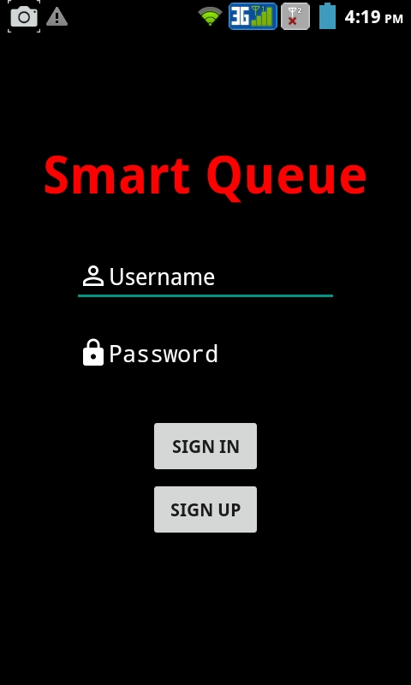

**Figure 5.1.1: Interface Design of Login**

This is the first screen of the application, when smart queuing system application is started, user may sign in with his/her existing user account at this login activity. User is required to fill in the username and password for the authentication in order to proceed to the next stage. In contrast, an error message will pop out for user when they filled in the incorrect username or password. User could re-try by entering the correct username or password until they obtain the authentication from the server. Besides that, user who are forgotten their username or password could register a new account. A sign up button is provided in this screen for the user to create a new account of the application. Figure 5.1.1 shows the login interface design of the application.

#### Registration

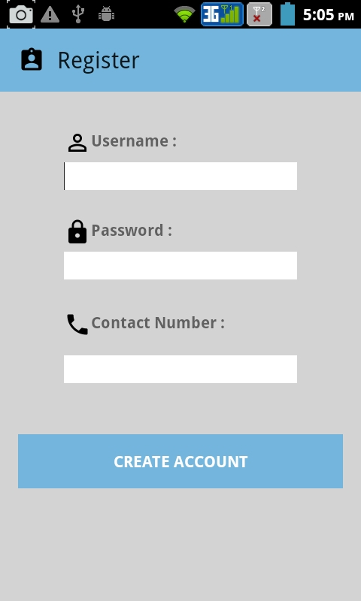

**Figure 5.1.2: Interface design of Login**

After pressing the sign up button, this registration activity will display on your android phone. Registration is required for every user. This registration form is design for users to register themselves to smart queuing system application. This registration activity contains a form for user to key in their personal information. All the fields are required to key in this form. Contact number of user is very important and need to insert correctly because sms notification will send to the contact number to notify user when the queuing number is almost reach. Besides that, username must be unique in this field in order to create a new account. After filled in all of the personal information and the new account is created, users are able login to the application by using the valid username and password. Figure 5.1.2 shows the register interface design of the application.

#### Main Menu

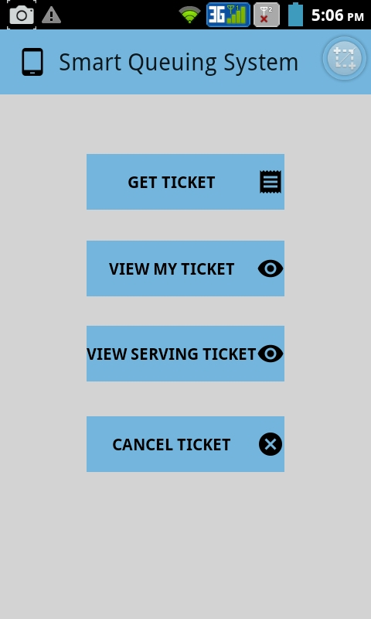

**Figure 5.1.3: Interface Design of Main Menu**

After login was successful, the main menu will display to the user. In the main menu activity, there are four buttons are available here. Each of the buttons had the different of function. User can get the queuing ticket, view their owned ticket, view the current serving ticket and as well as cancel the ticket in anytime. Figure 5.1.3 is the main menu of the application.

#### Get Ticket

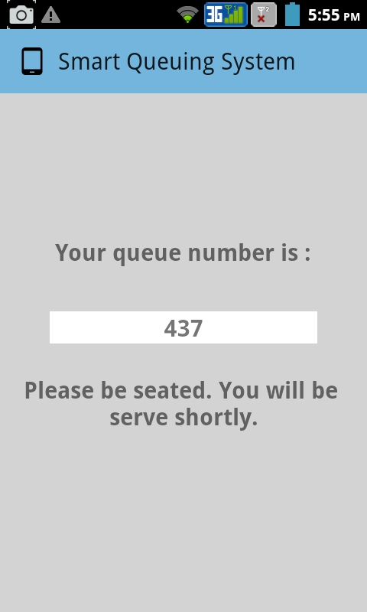

**Figure 5.1.4: Interface Design of Get Ticket**

When the user clicks the Get Ticket button, the interface will be change to another activity as the figure above. Therefore, user can obtain a paperless queuing ticket by using this application. The online e-Ticket will display on the screen for user after user pressing the get ticket button. In this example, number 437 is the ticket owned by the user. Every single user had the different queuing number and it is unique. Aside from that, the current user is not able to get another new ticket before the number 437 being served or deleted. Figure 5.1.4 shows the get ticket function of the application.

#### View My Ticket

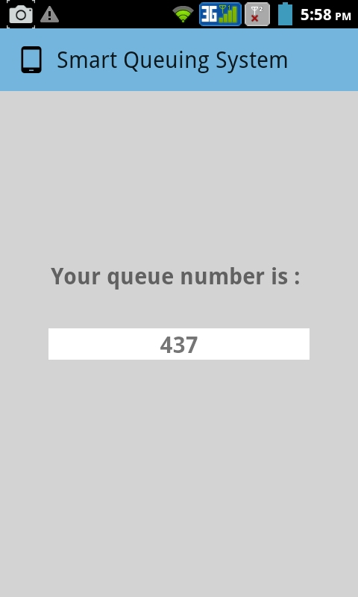

**Figure 5.1.5: Interface Design of View My Ticket**

At view my ticket activity, users can view back their online e-Ticket which were taken by themselves. The aim of this function is purposely created for user to view their ticket especially for the forgetful user. They are able to view back their online e-Ticket if they forget the queuing number. Figure 5.1.5 shows the view my ticket function of the application.

#### View Serving Ticket

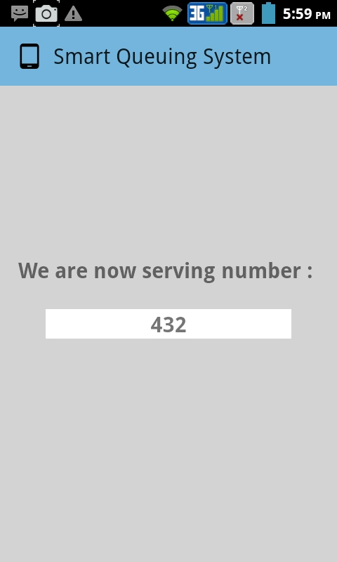

**Figure 5.1.6: Interface Design of View Serving Ticket**

At view serving ticket activity, user is able to view the current serving number on the application. User can get to know what number is having the service now and also able to do the comparison between how many numbers more to reach their turn. In this example, the user of number 432 is having the service right now. Figure 5.1.5 shows the view serving ticket function of the application.

#### Cancel Ticket

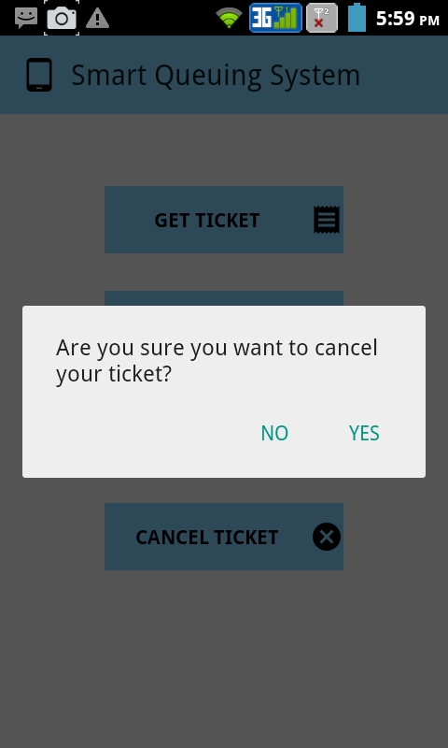

**Figure 5.1.7: Interface Design of Cancel Ticket**

At cancel ticket activity, user can cancel their online e-Ticket number when they want to give up the service. After user cancels the ticket, they are just qualified to get a new ticket. A user cannot get the second ticket before the first ticket being served or cancelled. Figure 5.1.7 shows the cancel ticket function of the application.

#### Administrator Login

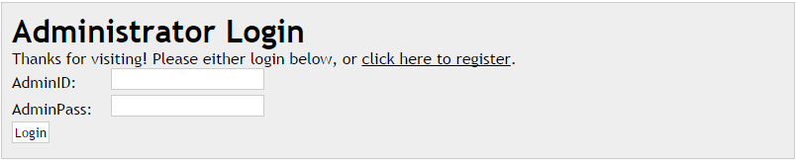

**Figure 5.1.8: Interface Design of Administrator Login**

The figure above is the login page for administrator side. Administrator needs to login in order to update the serving ticket. Administrator is required to have the admin ID and admin Password used to proceed to the administrator area. Figure 5.1.8 is the administration side login page.

#### Administrator Registration

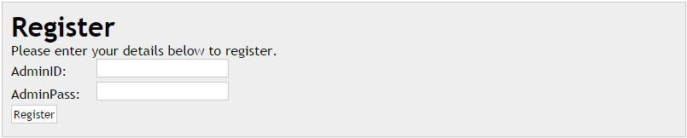

**Figure 5.1.9: Interface Design of Administrator Registration**

Administrator registration page is only allowed admin to register an account. Administrators have to register an account by fill in the admin ID and admin Password which are provided at the registration page. Once the registration is done, administrator can handle the update of the serving ticket. Figure 5.1.9 is the administration side registration page.

#### Dummy User Page

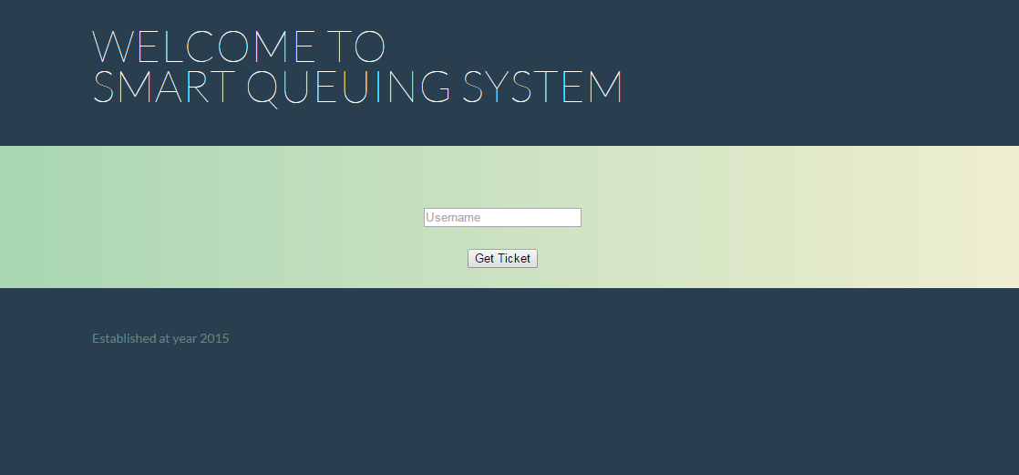

**Figure 5.1.10: Interface Design of Dummy User Page**

Dummy user page is created here because lacking of the quantity of android devices. The purpose of this page is to let the dummy user to obtain the online e-Ticket. Each android device only can obtain a ticket in the application to avoid the spamming case. Therefore, sms notification will send to the user when the services almost reach their turn. Figure 5.1.10 shows the dummy user web page.

#### Ticket for Dummy User

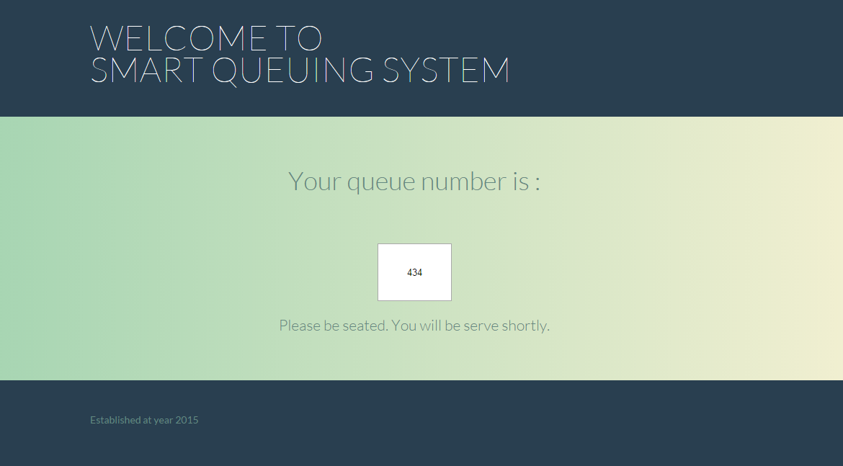

**Figure 5.1.11: Interface Design of Ticket for Dummy User**

After a dummy user fill in the username, an online e-Ticket will display for the dummy user. In this example, ticket number 434 is belongs to this dummy user. Therefore, the ticket number will update to the server and ticket number 434 is not longer available for another user before the ticket number is being reset. Figure 5.1.11 shows the dummy user get the online ticket.

#### Update Serving Ticket

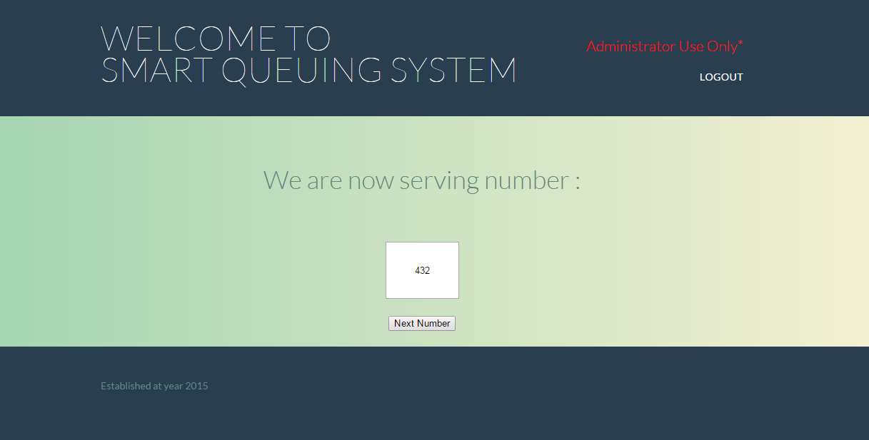

**Figure 5.1.12: Interface Design of Update Serving Ticket**

After administrator successfully login, this page will pop out for the administrator to update the serving ticket. Once the number 432 done the service, administrator will update the ticket by clicking the next number button. Therefore, user with the ticket number 433 can have the service because it is his/her turn. At this moment, ticket number 433 will be synchronized and user is able to view the current serving ticket on android phone. Figure 5.1.12 shows the web page for administrator to update the serving ticket.

#### SMS Notification

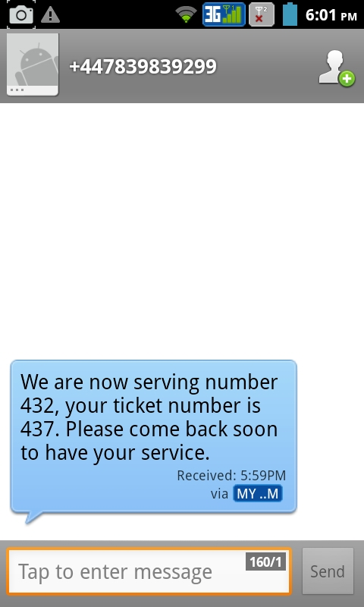

**Figure 5.1.13: SMS notification**

On the other hand, a SMS will send to the user via the contact number. The purpose of SMS is to notify the user about their ticket number is almost reach. One of the advantages of SMS notification is to avoid the user miss out their services. SMS notification will send to the user with the gap of 5 numbers earlier with the user’s ticket number. In this example, administrator is serving the ticket number 432 and the SMS notification will send to user who is owned the ticket number 437. Figure 5.1.13 shows that a SMS sent to user for the notification.

# THE IMPLEMENTATION PROCESS / RESULTS

### Preparations

Preparation is a very important process of making ready or being made ready for consideration or use of the system. Without preparation, the processing of the system could not be able to conduct smoothly. There are some several preparations need to be prepare before the implementation process begins. First of all, android development environment must be setup on the development system. Android software development kit (SDK) provides tools and APIs which are necessary used to developing applications on the Android environment. Therefore, most of the applications are normally developed in Java programming language by using the SDK. Java Development Kit (JDK) is needed for a development system to develop an application. Aside from that, Eclipse Integrated Development Environment (IDE) brings huge advantage when established an android applications because of its Android Development Tools (ADT) plugin. Lastly, PHP server and MYSQL database are also need to setup on the server in order to develop applications.

### Setup Eclipse Integrated Development Environment

1. The first step is to download the Java Development Kit (JDK) from <http://www.oracle.com/technetwork/java/javase/downloads/index.html>
2. The second step is to download the Eclipse Integrated Development Environment (IDE) from <http://www.eclipse.org/downloads/>
3. Run the Eclipse IDE and also setup the workspace path for your preferred directory.
4. Open the menu bar, select Help and choose Install New Software. Insert <https://dl-ssl.google.com/android/eclipse/> at the location field and proceed with the OK button.
5. Checking and make sure the Developer Tools and the necessary APIs are installed.
6. After installed everything, restart Eclipse IDE. Go to the Window and choose Preferences to select the directory for Android SDK.

### Setup Android Software Development Kit

1. Download the Android Software Development Kit (SDK) from <http://developer.android.com/sdk/index.html>
2. Start the Android SDK manager
3. Select ‘Accept All’ and click on the ‘Install’ button
4. At the menu bar, Select Tools > Manage AVD
5. In the Create new Android Virtual Device windows, select ‘Android 2.2 – API Level 8’ at the target. Then click on the ‘Create AVD’ button.

### Get Ticket

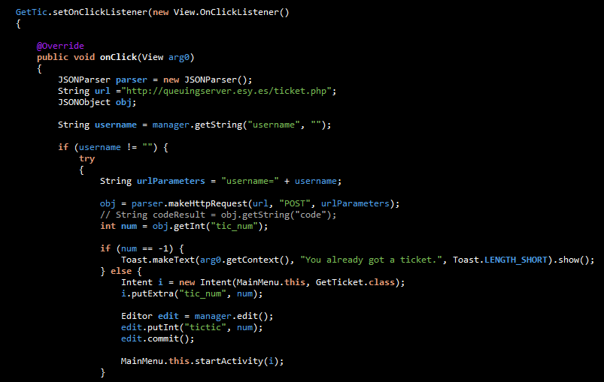

**Figure 6.1: Source Code for Get Ticket Function**

### View My Ticket

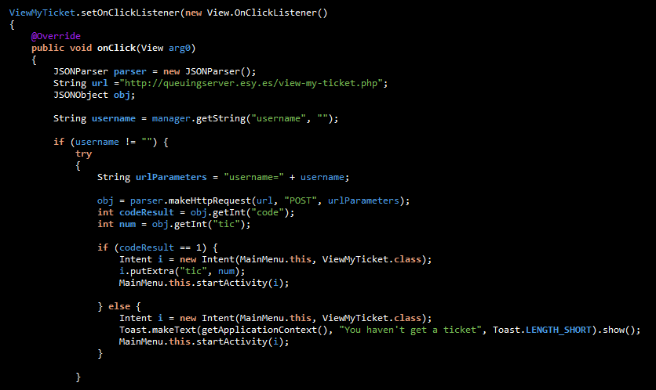

**Figure 6.2: Source Code for View My Ticket Function**

### View Serving Ticket

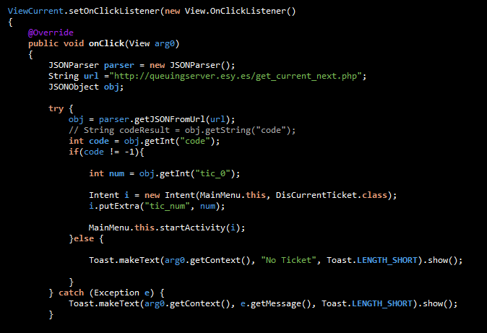

**Figure 6.3: Source Code for View Serving Ticket Function**

### Cancel Ticket

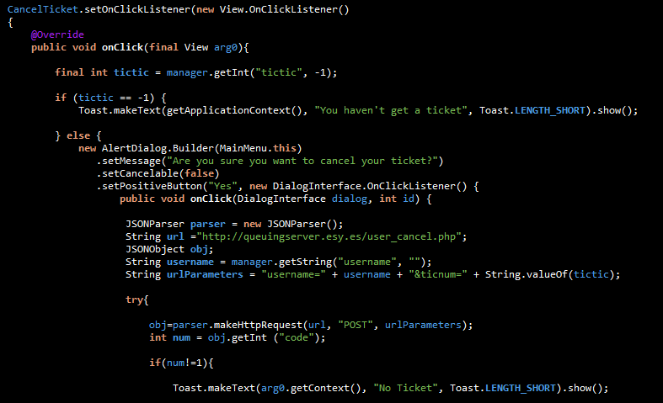

**Figure 6.4: Source Code for Cancel Ticket Function**

### Connection.php

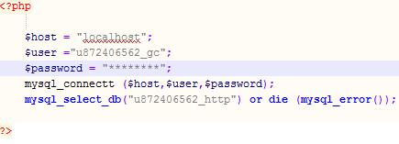

**Figure 6.5: Source Code for Connection.php**

### Sms.php

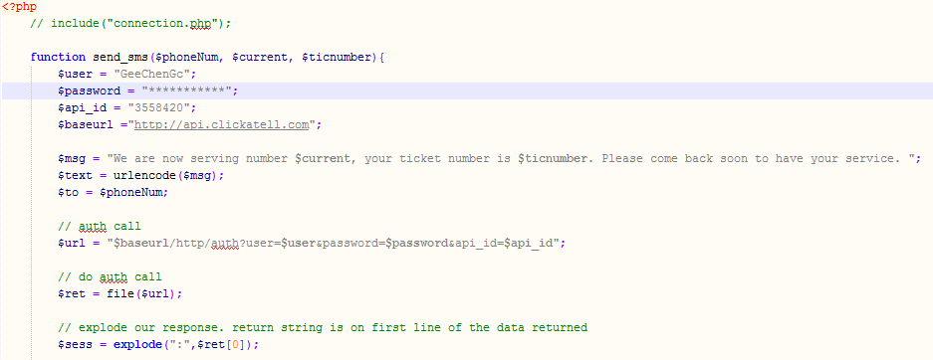

**Figure 6.6: Source Code for sms.php**

### Ticket.php

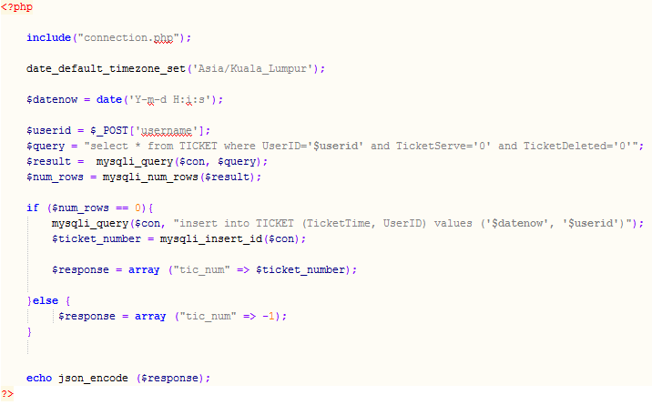

**Figure 6.7: Source Code for Ticket.php**

### View-my-ticket.php

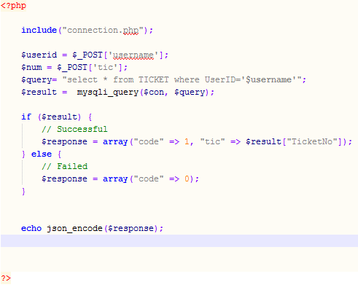

**Figure 6.8: Source Code for View-my-ticket.php**

### Get_current_next.php

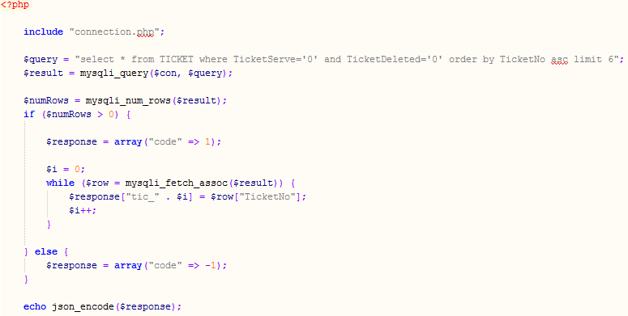

**Figure 6.9: Source Code for Get_current_next.php**

### User_cancel.php

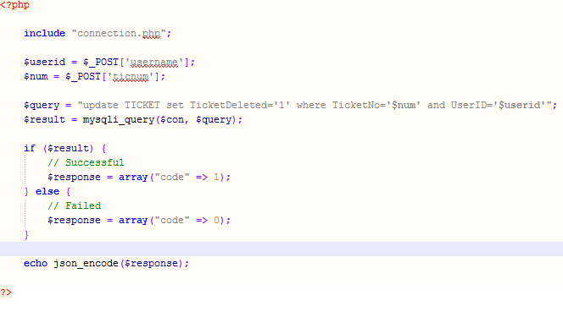

**Figure 6.10: Source Code for User_cancel.php**

# TESTING / EVALUATION OF FINDINGS

### Integration Testing

The aim of integration testing is to make sure that the system output is reach the satisfaction of functional requirement when more than one module are combined and implemented together. In this testing, the expected output for the every single test case will be recorded and used to compare with the system output. Besides that, test cases are used to evaluate the assumption that made in implementation phase. Figure 7.1 shows the integration testing report.

|  |  |  |  |
| --- | --- | --- | --- |
| **Module** | **Test Case** | **Expected Output** | **Result** |
| Registration | No internet connectivity | Block to access the module | Fulfil |
| Fill in the personal information | Successful and proceed to the login activity | Fulfil |
| Fill in the personal information with used username | Failed and display the error message | Fulfil |
| Login | No internet connectivity | Block to access the module | Fulfil |
| Fill in the personal information | Successful and proceed to the main menu activity | Fulfil |
| Fill in the wrong username or password | Failed and display error message | Fulfil |
| Get Ticket | No internet connectivity | Block to access the module | Fulfil |
| Active internet connectivity | Display the queuing ticket number | Fulfil |
| Get more than one ticket before ticket being served or deleted | Failed and display error message | Fulfil |
| View My Ticket | No internet connectivity | Block to access the module | Fulfil |
| Active internet connectivity | Display your owned ticket | Fulfil |
| View ticket before getting a ticket | Failed and display error message | Fulfil |
| View Serving Ticket | No internet connectivity | Block to access the module | Fulfil |
| Active internet connectivity | Display the current serving ticket | Fulfil |
| View serving ticket before serving | Failed and display error message | Fulfil |
| Cancel Ticket | No internet connectivity | Block to access the module | Fulfil |
| Active internet connectivity | Ticket is removed | Fulfil |
| Cancel ticket before getting a ticket | Failed and display error message | Fulfil |
| Administrator update serving ticket | No internet connectivity | Block to access the module | Fulfil |
| Active internet connectivity | Display updated ticket | Fulfil |
| Update ticket before user getting a ticket | Failed and display no ticket | Fulfil |
| SMS notification | Send sms notification to user when ticket is almost reach | Received a sms notification message | Fulfil |

**Table 7.1: Integration Testing Report**

### Validation Testing

In smart queuing application, the user is required to fill in the username and password. Therefore, those steps have to go through the validation process before the user data send to server. If the validation process success, the data will store to the server for the future use. In contrast, an error message will prompt to user if the validation is failed. The validation of activities is shown at Table below.

|  |  |
| --- | --- |
| **Activity** | **Validation** |
| Registration | * All fields are required to fill in * Username must be unique * Contact number must be numeric |
| Login | * All fields are required to fill in * Username and password must match with when user registered |

**Table 7.2: Activity Validation**

### Security Testing

Security testing is the process used to protect data and maintain functionality of the system. First of all, authentication is required by the system at the login activity. Users have to insert their username and password for the authentication purpose. Besides that, administration also required to login before entering to the system. In order to improve the security of the system, administrator’s password is hashed by the hashing function which is called md5. After the password is hashed, it is send to the server for authentication. Unfortunately, if the authentication is failed to authenticate with the server, the user is not allowed to access into the system and being block at the outside of the system.

### Mobile Testing

In mobile testing, smart queuing system application is installed on several different android devices. The mobile devices must be running on android mobile operation system but in different version of android operating system. The results are show at the table below.

|  |  |  |
| --- | --- | --- |
| **Mobile Device** | **Mobile Operating System** | **Remark** |
| Sony Ericsson Xperia X10i | Android 2.1 | Fine |
| Sony Ericsson Xperia X10i | Android 2.3.3 | Fine |
| Samsung Galaxy S II | Android 2.3.3 | Fine |
| Samsung Galaxy Ace | Android 2.2 | Fine |

**Table 7.2: Mobile Testing with Different Operating System**

### User Evaluation of the System

User evaluation is very important after they installed and perform the testing on the system. Therefore, the application can have a future enhancement or improvement of the system based on the user’s feedback. At this part, questionnaire must be provided for the user to answer. After user completed the questionnaire, the result will be collected and perform the analysis of the system. Only 20 questionnaire replies had been received from the different user. There are likely many reasons for the low number of responses but the fact remains that the result is still a cause for concern.

Of the 20 replies received, the answers were provided by the user had responses positive. There are 5 questionnaire question provided for the user in this task. User should answer every question before they submit the questionnaire form. Based on the 20 replies, the statistics diagrams of the question were performed.

#### Simple to Use

The first question is related to the level of difficulties to implement the system. The vast majority of respondents, 50%, strongly agree that the smart queuing system is easy to use. The result are shown in the figure 7.1. None of the respondent deemed that the system have the high difficulty to use.

**Figure 7.1: User Evaluate the Difficulties Level of the System**

#### User Friendly Interfaces

The second question was asked about the friendliness of the system. Over 50 of the respondents confirmed that the interface of the system is very friendly. That is only 5% of the respondents deemed about the interface of the system was complex.

**Figure 7.2: Opinion on User Friendly Interfaces**

#### Convenience to User

Next, question three was asked about convenience of the system brings to the user. There are 70% of the respondents strongly agree that the system is very convenience. Total 90% of respondents are agreed about this question. The questionnaire result is shown in the pie chart as below.

**Figure 7.3: Opinion on Convenience of the System**

#### Learning to Use

Next, question four was asked about whether the user would learn to use the system very quickly. The result based on the questionnaire show that 70% of the user is able to learn the system in a short time. The result of this question is shown at the graph below.

**Figure 7.4: Opinion on Learning of the System**

#### Introduce the System

The last question in the questionnaire was asked about whether the user will introduce the system to their friend and family. The vast majority of respondents, 80%, would like to share and spread this system for their friends and family. There is only 10% of the respondents do not share the system with others. The results are shown in the figure below.

**Figure 7.5: Opinion on Sharing the System to others**

### Questionnaire

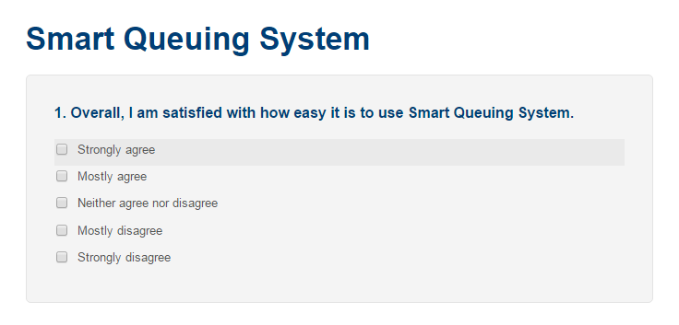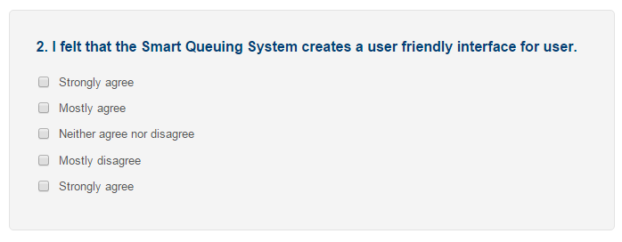

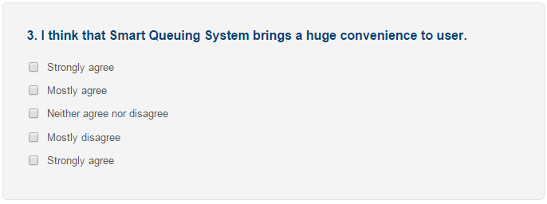

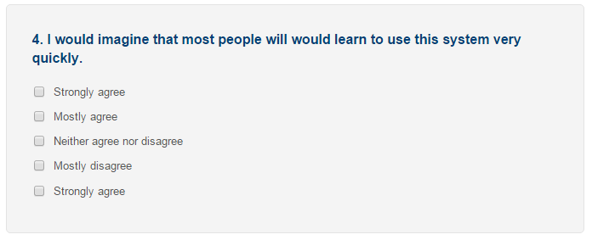



# CONCLUSION

The use of smartphone is becoming more and more widespread and affordable in the new century. Therefore, mobile smartphone users now prefer to obtain their ticket by using their smartphone application, turning their smartphone into a portable ticket system. In this project, we reviewed most of the existing queuing system implemented by different company and create our own smart queuing system mobile application.

Smart Queuing System is very useful when there is a customer service need to queue up a couple of time. It has brings advantages to all of the users when waiting in the queuing line. Moreover, it also provides a huge convenience to the user especially those people who are not have much patient when waiting to be served.

Besides, research will be still conducted and the new requirements will be keeps updating on new techniques in order to implement into smart queuing system for better system efficiency.

**Future Enhancement**

In future, smart queuing system applications are able to improve in some certain aspects. The future direction for this work will include the implementation of this solution model in other mobile platforms, mainly the IOS and Windows Phone. A stronger security mechanism put in place will also ensure a greater login process by required the mixed up alphabet or punctuation or many more as password. It may take time to hack in and not easy being hack.

REFERENCES

AmitChauhan, ReechaRanjan Singh, SangeetaAgrawal, SaurabhKapoor,S.Sharma., 2011, “SMS based Remote Control System,” IJCSMS International Journal of Computer Science and Management Studies,11(02), pp.19 – 24

A. Sarka, (2011), “Modeling and Simulation of a Bank Queuing System “, Universiti Teknologi , Malaysia.

B u n d a y , B.D., An Introduction to Queuing Theory, New York: Halsted Press, 1996

B. Zudiana, (2006), ” Alert Notification Via Sms”, Mara University Of Technology

D. Gross, J. F. Shortle, J. M. Thompson, and C. M. Harris.Fundamentals of Queueing Theory. Wiley-Interscience,2008.

G o r n e y , L, Queuing Theory: A Problem Solving Approach, New York: Petrocelli Booko, Inc.

G r o s s, D., H a r r i s , C.M., Fundamentals of Queuing Theory. New York: John Wiley, Second

M e d h i , J., Stochastic Models in Queuing Theory. Amsterdam: Academic press, Second Edition

M. Lothar, (2014), “Queue Management with SMS Notification”, Fraunhofer Heinrich Hertz Institute

MohdHelmy, AbdWahab, Norzilawati Abdullah, AyobJohari, Herdawatie Abdul Kadir., 2010, “GSM Based Electrical Control System for Smart Home Application,” Journal of Convergence Information Technology, 5(01), pp.33 – 39

N o s e k , A.R., W i s l o n , P. J., Queuing Theory and Customer Satisfaction: A Review of

R. F. Cope III, R. F. Cope, and H. E. Davis. Disney’s virtual queues: A strategic opportunity to co-brand services? Journal of Business & Economics Research, 2011 19812003.Edition, 1985.

S i n g h , V., Use of Queuing Models in Health Care, Department of Health Policy and Management,University of Arkanses for medical science, 2007

APPENDICES

**Appendix A: Meeting Log**

Appendix B

**Checklist for FYP Submission Form**



Faculty of Information Science and Technology (FIST)

**Final Year Project Meeting Log**

|  |  |
| --- | --- |
| **MEETING DATE:** | **MEETING NO.:** |
| **PROJECT ID:** |  |
| **PROJECT TITLE :** | |
| **SESSION :** | **SUPERVISOR :** |
| **STUDENT ID & Name:** | **CO- SUPERVISOR :** |

All to be filled in by student

|  |
| --- |
| **1. WORK DONE** [Please write the details of the work done after the last meeting.] |
| **2. WORK TO BE DONE** |
| **3. PROBLEMS ENCOUNTERED** |
| **4. COMMENTS** |

|  |  |  |  |  |
| --- | --- | --- | --- | --- |
| Supervisor’s Signature & Stamp |  | Co-Supervisor’s Signature & Stamp (if any) |  | Student’s Signature |

**NOTES**:

1. Items 1 – 3 are to be completed by the students before coming for the meeting. Item 4 is to be completed by the supervisor.
2. For FYP Phase 1, total six log sheets are to be submitted (every other week*).
3. For FYP Phase 2, total six log sheets are to be submitted (every other week**).
4. Log sheets are compulsory assessment criteria for FYP. Student who fails to meet the requirements of log sheets will not be allowed to submit FYP report.

*: week 1, 3, 5, 7, 9, 11 or 2, 4, 6, 8, 10 of the first trimester (week 11: report submission, weeks 13&14: presentation)

**: week 1, 3, 5, 7, 9, 11 or 2, 4, 6, 8, 10 of the second trimester (week 11: report submission, weeks 13&14: presentation)